Learners’ Academy

Developed by- Ishaan Gautam

[Email-ishaangautam1998@gmail.com](mailto:Email-ishaangautam1998@gmail.com)

**Project Summary**

* **Description-** The Objective of the project is to create a system that can help a school administrator manage subjects/teachers/students/Classes.
  + We have achieved this using 4 tables in the phase2project database. (the sql file for creating the database and the tables is provided with name- Initialize tables.sql). Please run the sql file in MySQL before running the project.
  + Database details used-
    - Class.forName("com.mysql.cj.jdbc.Driver");
    - String url = "jdbc:mysql://localhost:3306/phase2project";
    - String username = "root";
    - String password = "root";
  + The username and password selected for the system is “admin” and “admin” respectively.
  + The flow of adding elements is as described in the flowchart below-

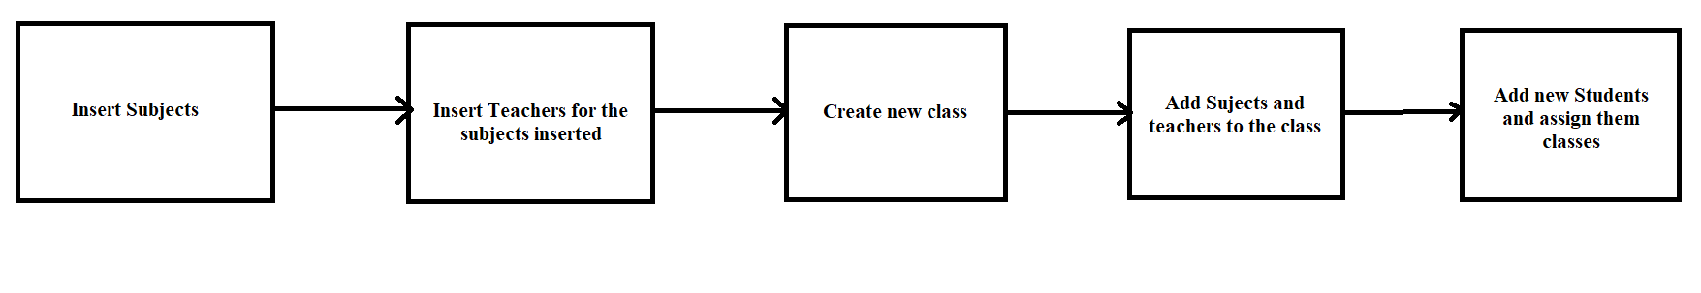

* + We have designed the system in such a way that will lead to minimal errors from user and minimal interruptions with many failsafes provided using if-else loops.
  + We have created an error jsp page which will automatically logout the user in case of any invalid input.
  + We have used cookies for handling session.
  + The Class names should be in Roman numbers.
  + All the dropdown menus shown in the below screenshots are dynamic. The options are retrieved from the database.
  + We have used minimal hard-coded variables so that the project can be as dynamic as possible.
  + Github link - https://github.com/IshaanGautam1/Phase2Project.git
* Total number of sprints for the project done – 5
  + **SPRINT-1**
    - Code developed for Login page, dashboard and logout page.
  + **SPRINT-2**
    - Database and tables created in MySQL. Code developed for adding subjects
  + **SPRINT-3**
    - Code developed for adding teachers.
  + **SPRINT-4**
    - Code developed for adding classes, adding subjects to classes and the error page.
  + **SPRINT-5**
    - Code developed for adding subjects to the classes and viewing class reports.
* Major Concepts used-
  + Servlets
  + MySQL
  + JSP
  + Exception Handling
  + HTML
  + Collections
* Screenshots-
  + Login Page-
    - 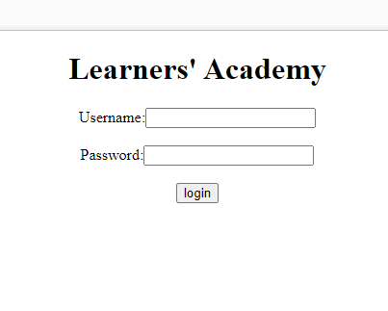
  + Dashboard-
    - 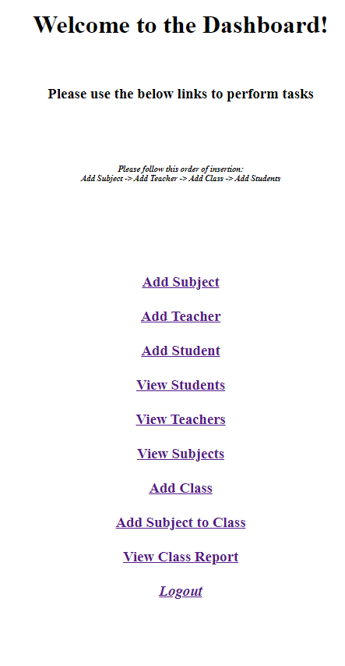
  + Adding Subjects-
    - 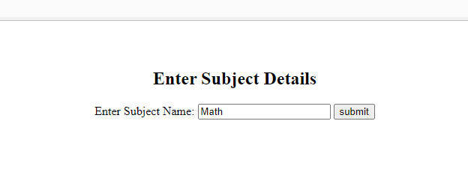
    - 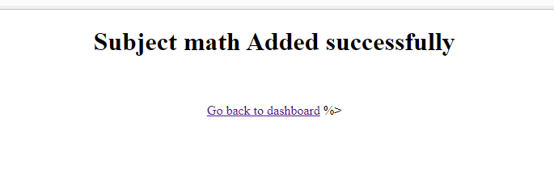
  + Adding Teachers-
    - 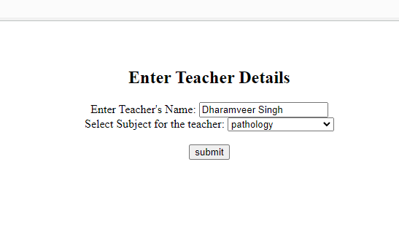
    - 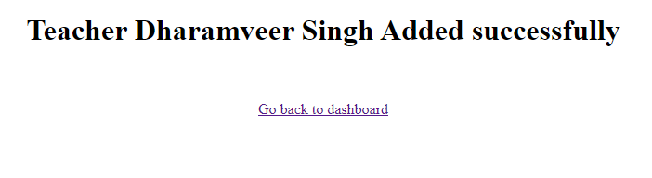
  + Adding Class-
    - 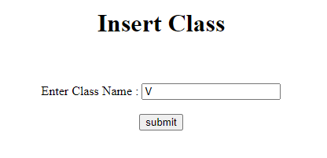
    - 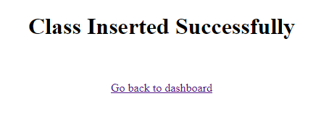
  + Adding Subject to class
    - 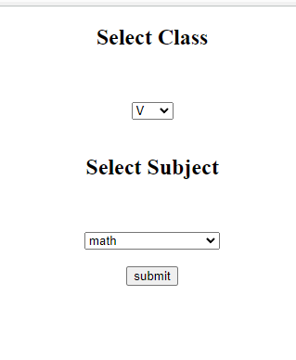
    - 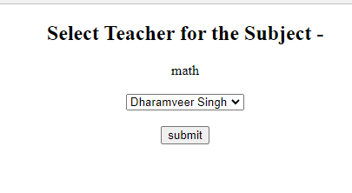
    - 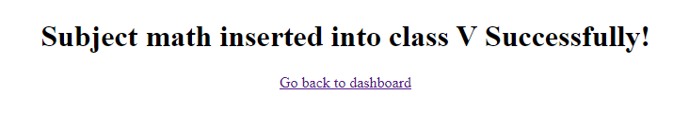
  + Adding Student to a class
    - 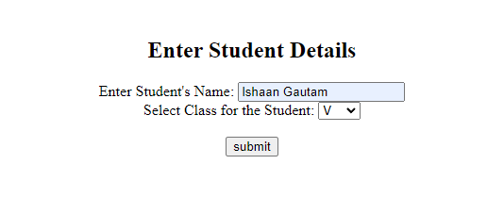
    - 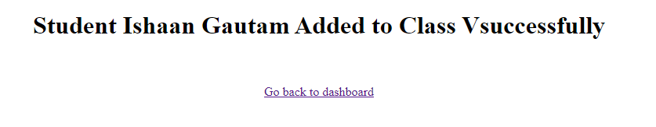
  + Viewing Subjects
    - 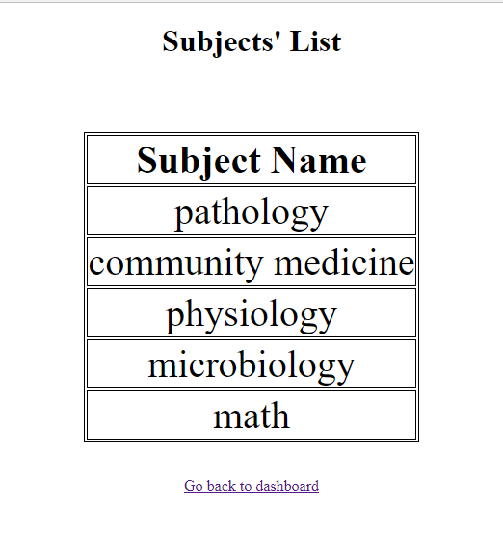
  + Viewing Teachers-
    - 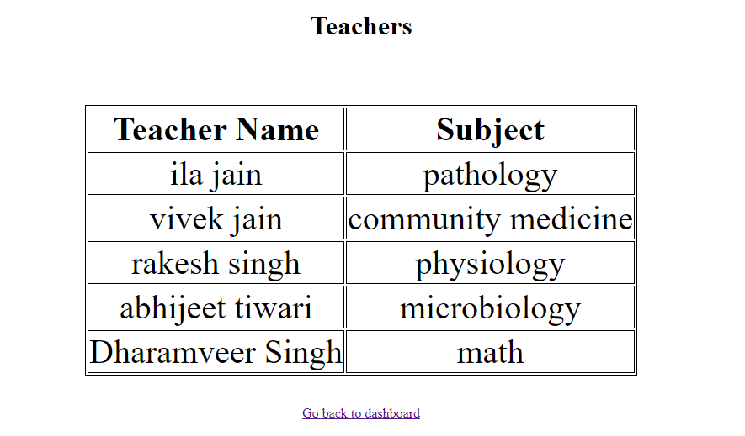
  + Viewing All Students list-
    - 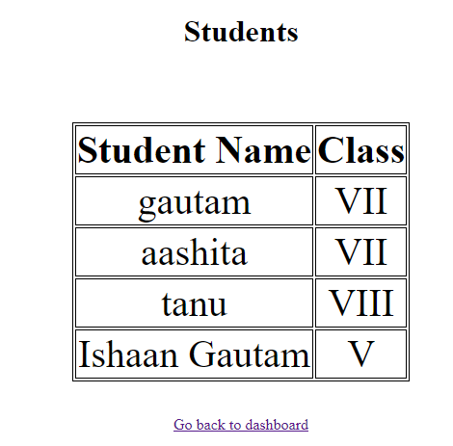
  + Viewing Class Reports-
    - 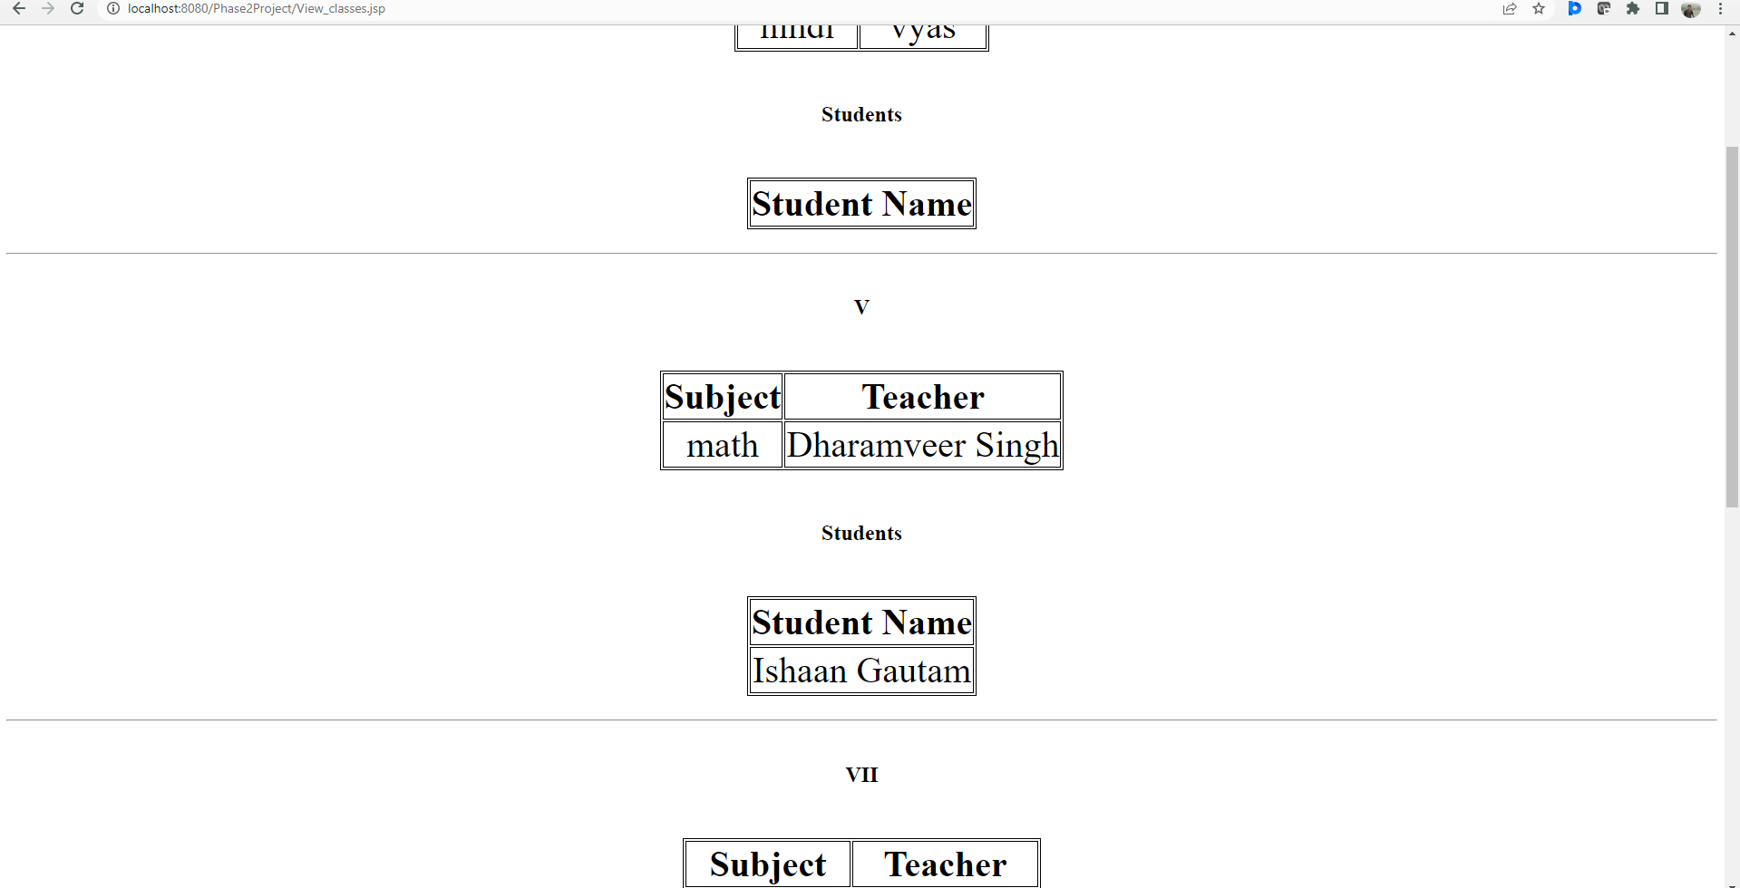
  + Error Page-
    - 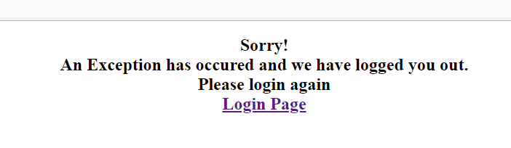
  + Tables in the phase2project database-
    - 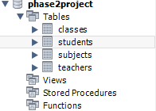
  + Initialize tables.sql file-
    - 